**598 Project 1**

**Weichuan Deng**

**112516608**

1. R code for mapping

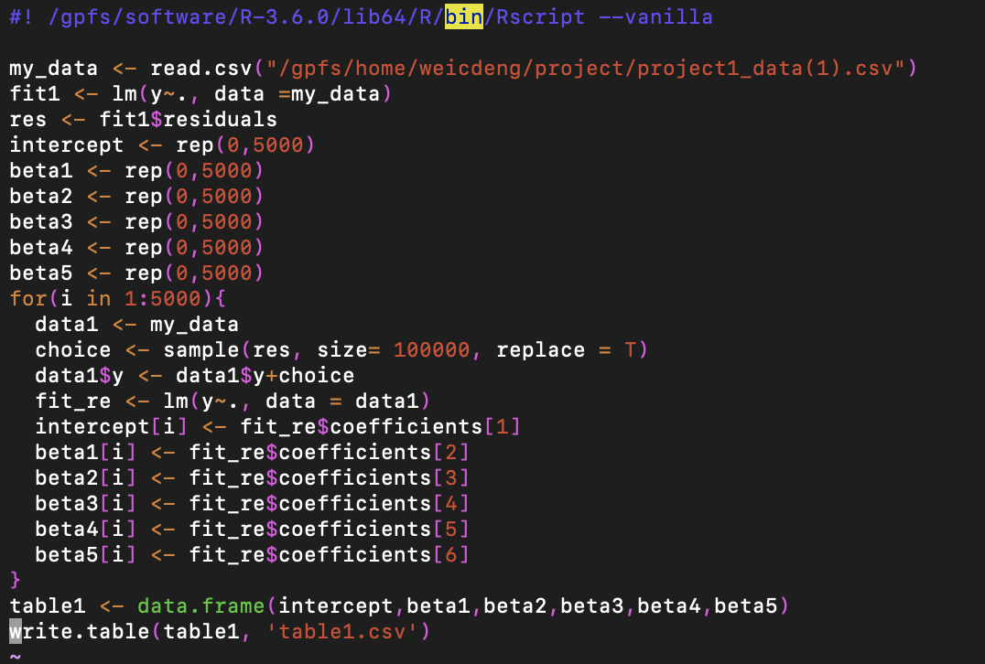

For mapping part, I divide 50000 times bootstrap to 10 5000 times bootstrap files. The code for those 10 files are similar. I just change the output table name of these R code.

Then I can get 10 table, each table will contain 5000 times bootstrap’s coefficients. 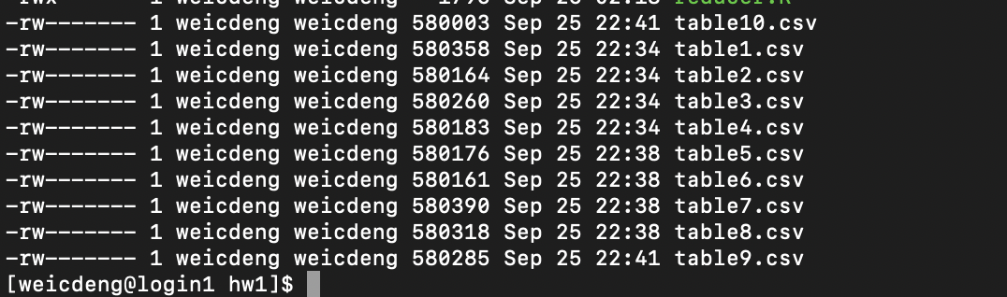

1. R code for reducing part

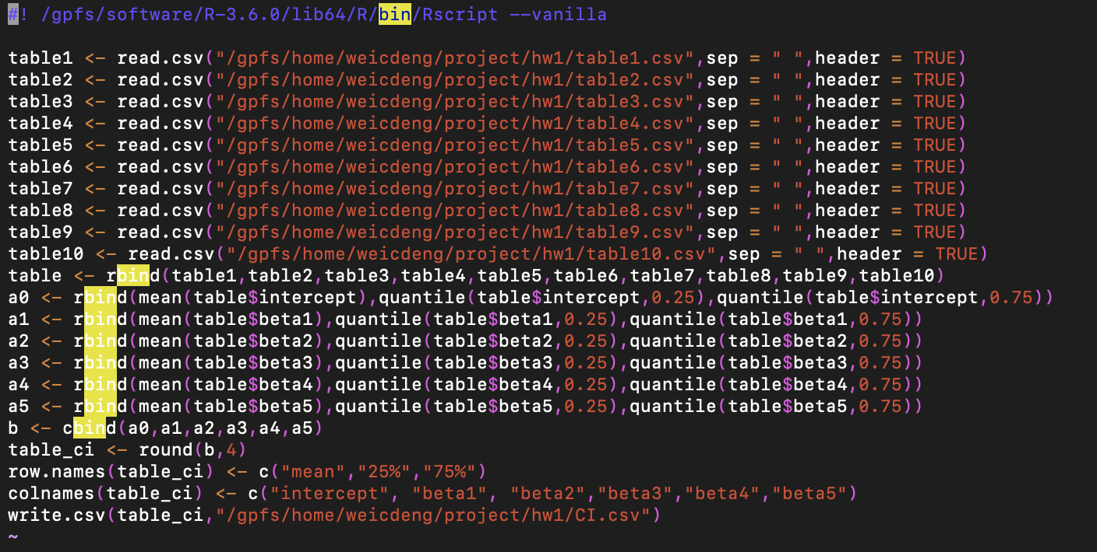

Read these tables in. And combine 10 tables to 1 table which contains 50000 times bootstrap coefficient of the linear regression. The last step is use “quantile” function to get the 25% and 75% percentile of the table. And we can get the 25%-75% confidence interval. Then, I round the confidence interval table to 4 digits and write into a csv file.

1. Slurm method for submission

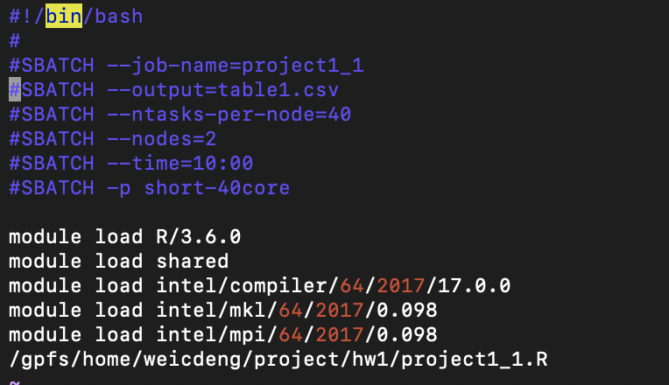

I also write 10 Slurm files for submission.

1. Result

Download the result from the seawulf.

